GABINETE PSICOLÓGICO
DOCTOR/A: ________________________

PACIENTE: SARA
CARÁCTER: _______________________________ ___________________________________________
CAMBIOS EN EL CARÁCTER: ______________
____________________________________________

___________________________________________________________________________________________________________________________________________________________________________________________________________________________________________________________________________________________________________________________________________________________________________________________________________________________________________

___________________________________________________________________________________________________________________________________________________________________________________________________________________________________________________________________________________________________________________________________________________________________________________________________________________________________________

______________________________________________________________________________________________________________________________________________________________________________________________________________________________________________________________________________________________________________________________________________________________________________________________________________________________________________

ANÁLISIS DE LAS RELACIONES CON SU ENTORNO
(pareja, familia, amigos, trabajo…)

DIAGNÓSTICO DE SUS PROBLEMAS

CONSEJOS PARA SOLUCIONAR DICHOS PROBLEMAS

___________________________________________________________________________________________________________________________________________________________________________________________________________________________________________________________________________________________________________________________________________________________________________________________________________________________________________

___________________________________________________________________________________________________________________________________________________________________________________________________________________________________________________________________________________________________________________________________________________________________________________________________________________________________________

______________________________________________________________________________________________________________________________________________________________________________________________________________________________________________________________________________________________________________________________________________________________________________________________________________________________________________
GABINETE PSICOLÓGICO
PACIENTE: MANU
CARÁCTER: _______________________________ ___________________________________________
CAMBIOS EN EL CARÁCTER: ______________
____________________________________________

DOCTOR/A: ________________________

ANÁLISIS DE LAS RELACIONES CON SU ENTORNO
(pareja, familia, amigos, trabajo…)
DIAGNÓSTICO DE SUS PROBLEMAS
CONSEJOS PARA SOLUCIONAR DICHOS PROBLEMAS

CONSEJOS PARA SOLUCIONAR DICHOS PROBLEMAS
DIAGNÓSTICO DE SUS PROBLEMAS
GABINETE PSICOLÓGICO
PACIENTE: TOMÁS
CARÁCTER: _______________________________ ___________________________________________
CAMBIOS EN EL CARÁCTER: ______________
____________________________________________

___________________________________________________________________________________________________________________________________________________________________________________________________________________________________________________________________________________________________________________________________________________________________________________________________________________________________________

___________________________________________________________________________________________________________________________________________________________________________________________________________________________________________________________________________________________________________________________________________________________________________________________________________________________________________

______________________________________________________________________________________________________________________________________________________________________________________________________________________________________________________________________________________________________________________________________________________________________________________________________________________________________________
ANÁLISIS DE LAS RELACIONES CON SU ENTORNO
(pareja, familia, amigos, trabajo…)
DOCTOR/A: ________________________

CONSEJOS PARA SOLUCIONAR DICHOS PROBLEMAS
DIAGNÓSTICO DE SUS PROBLEMAS
ANÁLISIS DE LAS RELACIONES CON SU ENTORNO
(pareja, familia, amigos, trabajo…)
GABINETE PSICOLÓGICO
PACIENTE: MARIO
CARÁCTER: _______________________________ ___________________________________________
CAMBIOS EN EL CARÁCTER: ______________
____________________________________________

___________________________________________________________________________________________________________________________________________________________________________________________________________________________________________________________________________________________________________________________________________________________________________________________________________________________________________

___________________________________________________________________________________________________________________________________________________________________________________________________________________________________________________________________________________________________________________________________________________________________________________________________________________________________________

______________________________________________________________________________________________________________________________________________________________________________________________________________________________________________________________________________________________________________________________________________________________________________________________________________________________________________
DOCTOR/A: ________________________

___________________________________________________________________________________________________________________________________________________________________________________________________________________________________________________________________________________________________________________________________________________________________________________________________________________________________________

___________________________________________________________________________________________________________________________________________________________________________________________________________________________________________________________________________________________________________________________________________________________________________________________________________________________________________

______________________________________________________________________________________________________________________________________________________________________________________________________________________________________________________________________________________________________________________________________________________________________________________________________________________________________________
PACIENTE: IRENE
CARÁCTER: _______________________________ ___________________________________________
CAMBIOS EN EL CARÁCTER: ______________
____________________________________________

GABINETE PSICOLÓGICO
DOCTOR/A: ________________________
CONSEJOS PARA SOLUCIONAR DICHOS PROBLEMAS
DIAGNÓSTICO DE SUS PROBLEMAS
ANÁLISIS DE LAS RELACIONES CON SU ENTORNO
(pareja, familia, amigos, trabajo…)

DIAGNÓSTICO DE SUS PROBLEMAS
ANÁLISIS DE LAS RELACIONES CON SU ENTORNO
(pareja, familia, amigos, trabajo…)

___________________________________________________________________________________________________________________________________________________________________________________________________________________________________________________________________________________________________________________________________________________________________________________________________________________________________________

___________________________________________________________________________________________________________________________________________________________________________________________________________________________________________________________________________________________________________________________________________________________________________________________________________________________________________

______________________________________________________________________________________________________________________________________________________________________________________________________________________________________________________________________________________________________________________________________________________________________________________________________________________________________________
PACIENTE: ANA
CARÁCTER: _______________________________ ___________________________________________
CAMBIOS EN EL CARÁCTER: ______________
____________________________________________

GABINETE PSICOLÓGICO
DOCTOR/A: ________________________
CONSEJOS PARA SOLUCIONAR DICHOS PROBLEMAS



___________________________________________________________________________________________________________________________________________________________________________________________________________________________________________________________________________________________________________________________________________________________________________________________________________________________________________

___________________________________________________________________________________________________________________________________________________________________________________________________________________________________________________________________________________________________________________________________________________________________________________________________________________________________________

______________________________________________________________________________________________________________________________________________________________________________________________________________________________________________________________________________________________________________________________________________________________________________________________________________________________________________
PACIENTE: ANDRÉS
CARÁCTER: _______________________________ ___________________________________________
CAMBIOS EN EL CARÁCTER: ______________
____________________________________________

GABINETE PSICOLÓGICO
DOCTOR/A: ________________________
CONSEJOS PARA SOLUCIONAR DICHOS PROBLEMAS
DIAGNÓSTICO DE SUS PROBLEMAS
ANÁLISIS DE LAS RELACIONES CON SU ENTORNO
(pareja, familia, amigos, trabajo…)

CONSEJOS PARA SOLUCIONAR DICHOS PROBLEMAS
DIAGNÓSTICO DE SUS PROBLEMAS
ANÁLISIS DE LAS RELACIONES CON SU ENTORNO
(pareja, familia, amigos, trabajo…)

___________________________________________________________________________________________________________________________________________________________________________________________________________________________________________________________________________________________________________________________________________________________________________________________________________________________________________

___________________________________________________________________________________________________________________________________________________________________________________________________________________________________________________________________________________________________________________________________________________________________________________________________________________________________________

______________________________________________________________________________________________________________________________________________________________________________________________________________________________________________________________________________________________________________________________________________________________________________________________________________________________________________
PACIENTE: SOFÍA
CARÁCTER: _______________________________ ___________________________________________
CAMBIOS EN EL CARÁCTER: ______________
____________________________________________

GABINETE PSICOLÓGICO
DOCTOR/A: ________________________

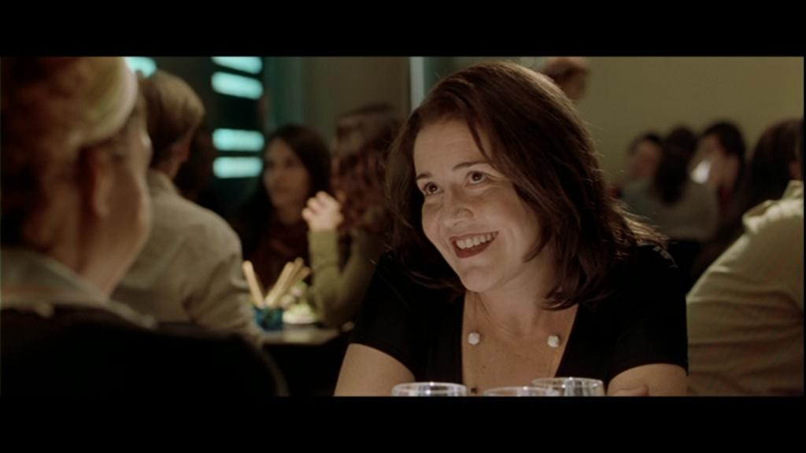

DOCTOR/A: ________________________
CONSEJOS PARA SOLUCIONAR DICHOS PROBLEMAS
DIAGNÓSTICO DE SUS PROBLEMAS
ANÁLISIS DE LAS RELACIONES CON SU ENTORNO
(pareja, familia, amigos, trabajo…)
GABINETE PSICOLÓGICO
PACIENTE: CRISTINA
CARÁCTER: _______________________________ ___________________________________________
CAMBIOS EN EL CARÁCTER: ______________
____________________________________________

___________________________________________________________________________________________________________________________________________________________________________________________________________________________________________________________________________________________________________________________________________________________________________________________________________________________________________

___________________________________________________________________________________________________________________________________________________________________________________________________________________________________________________________________________________________________________________________________________________________________________________________________________________________________________

______________________________________________________________________________________________________________________________________________________________________________________________________________________________________________________________________________________________________________________________________________________________________________________________________________________________________________



CONSEJOS PARA SOLUCIONAR DICHOS PROBLEMAS
DIAGNÓSTICO DE SUS PROBLEMAS
GABINETE PSICOLÓGICO
PACIENTE: EVA
CARÁCTER: _______________________________ ___________________________________________
CAMBIOS EN EL CARÁCTER: ______________
____________________________________________

___________________________________________________________________________________________________________________________________________________________________________________________________________________________________________________________________________________________________________________________________________________________________________________________________________________________________________

___________________________________________________________________________________________________________________________________________________________________________________________________________________________________________________________________________________________________________________________________________________________________________________________________________________________________________

______________________________________________________________________________________________________________________________________________________________________________________________________________________________________________________________________________________________________________________________________________________________________________________________________________________________________________
ANÁLISIS DE LAS RELACIONES CON SU ENTORNO
(pareja, familia, amigos, trabajo…)
DOCTOR/A: ________________________



GABINETE PSICOLÓGICO
PACIENTE: SILVIA
CARÁCTER: _______________________________ ___________________________________________
CAMBIOS EN EL CARÁCTER: ______________
____________________________________________

___________________________________________________________________________________________________________________________________________________________________________________________________________________________________________________________________________________________________________________________________________________________________________________________________________________________________________

___________________________________________________________________________________________________________________________________________________________________________________________________________________________________________________________________________________________________________________________________________________________________________________________________________________________________________

______________________________________________________________________________________________________________________________________________________________________________________________________________________________________________________________________________________________________________________________________________________________________________________________________________________________________________
ANÁLISIS DE LAS RELACIONES CON SU ENTORNO
(pareja, familia, amigos, trabajo…)
DIAGNÓSTICO DE SUS PROBLEMAS
CONSEJOS PARA SOLUCIONAR DICHOS PROBLEMAS
DOCTOR/A: ________________________



GABINETE PSICOLÓGICO
PACIENTE: ERIC
CARÁCTER: _______________________________ ___________________________________________
CAMBIOS EN EL CARÁCTER: ______________
____________________________________________

___________________________________________________________________________________________________________________________________________________________________________________________________________________________________________________________________________________________________________________________________________________________________________________________________________________________________________

___________________________________________________________________________________________________________________________________________________________________________________________________________________________________________________________________________________________________________________________________________________________________________________________________________________________________________

______________________________________________________________________________________________________________________________________________________________________________________________________________________________________________________________________________________________________________________________________________________________________________________________________________________________________________
ANÁLISIS DE LAS RELACIONES CON SU ENTORNO
(pareja, familia, amigos, trabajo…)
DIAGNÓSTICO DE SUS PROBLEMAS
CONSEJOS PARA SOLUCIONAR DICHOS PROBLEMAS
DOCTOR/A: ________________________



