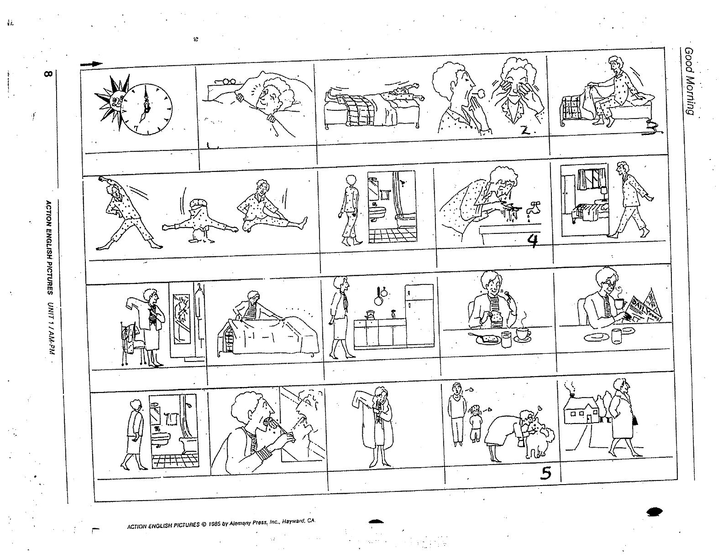

¿CUÁL ES LA RUTINA DE LA SEÑORA RODRIGUEZ?

Contar y continuar la historia.

____________________________________________________________________________________________________________________________________________________________________________________________________________________________________________________________________________________________________________________________________________________________________________________________________________________________________________________________________________________________________________________________________________________________________________________________________________________________________________________________________________________________________________________________________________________________________________________________________________________________________________________________________________________________________________________________________________________________________________________________________________________

